ASSIGNMENT_3

Q1 – Constructors and Constructor Overloading 6 Marks
Bloom’s Level: K5 – Evaluate
Problem Context – Library Book Records
A library creates Book objects in several situations: a new book with full details, a donated book with only a title, and an empty record that will be filled later. Some records were created with garbage values in the number of copies.
Implementation Tasks
You must:
- Write a default constructor, a parameterised constructor and overloaded constructors for the three situations
- Use a member initializer list in every constructor
- Use constructor delegation to avoid repeating code
- Show that no Book can be created with an invalid number of copies
Design & Analysis
You must:
- Explain when the compiler supplies a default constructor and when it does not
- Explain why member initializer lists are preferred to assignment inside the constructor body
- Explain the order in which members are initialised (declaration order, not list order)
- Draw the state of three objects after construction
Experimental Investigation
You must:
- Create Book objects with every constructor and print them
- Remove the default constructor and record the compiler error when an array of Books is created
- Demonstrate a member initialised in the wrong order and the -Wreorder warning
- Test a negative number of copies
Design Question
When should a constructor be marked explicit? Show a call that compiles without explicit and fails with it.
Alternative Concept and Complexity Analysis
If one constructor with default arguments (Book(std::string t = "", int copies = 0, ...)) were used instead of several overloaded constructors and delegation, what would the solution be? Analyse the time and space of object creation (O(1) in both) and compare which design checks the number of copies in fewer places.
CODE:
#include <iostream>
#include <stdexcept>
#include <string>

class Book {
private:
std::string title;
std::string author;
int copies;

static int validateCopies(int count) {
if (count < 0) {
throw std::invalid_argument("Number of copies cannot be negative.");
}
return count;
}

public:
// Default constructor: an empty record to fill in later.
Book() : Book("", "", 0) {}

// Donated book: title only, with one copy.
explicit Book(const std::string& bookTitle) : Book(bookTitle, "", 1) {}

// Parameterized constructor: full book details.
Book(const std::string& bookTitle, const std::string& bookAuthor, int count)
: title(bookTitle),
author(bookAuthor),
copies(validateCopies(count)) {}

void print() const {
std::cout << "Title: " << (title.empty() ? "(empty)" : title)
<< ", Author: " << (author.empty() ? "(unknown)" : author)
<< ", Copies: " << copies << '\n';
}
};

int main() {
try {
Book emptyRecord;
Book donatedBook("The Hobbit");
Book fullBook("1984", "George Orwell", 5);

std::cout << "Objects after construction:\n";
emptyRecord.print();
donatedBook.print();
fullBook.print();

// Invalid construction throws std::invalid_argument.
Book invalidBook("Invalid Book", "Unknown", -2);
} catch (const std::invalid_argument& error) {
std::cout << "Could not create book: " << error.what() << '\n';
}
}
OUTPUT:
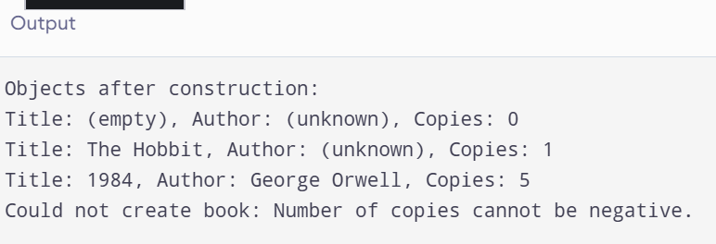
Q2 – Copy Constructors: Shallow and Deep Copies (7 Marks)
Bloom’s Level: K5 – Evaluate
Problem Context – Hospital Prescription Records
A Prescription object holds a dynamically allocated array of medicine names. When a doctor copies a prescription to modify it for a follow-up visit, the original prescription also changes, and the program sometimes crashes when it ends.
Implementation Tasks
You must:
- Implement the class first without a copy constructor and observe the problem
- Implement a deep-copying copy constructor, a copy assignment operator and a destructor
- Verify that copies are independent
- Run the program under -fsanitize=address (or Valgrind) for both versions
Design & Analysis
You must:
- Draw memory diagrams for a shallow copy and a deep copy
- Explain why the shallow version crashes at the end (double delete)
- State the Rule of Three and explain why the three functions go together
- Explain the three situations in which the copy constructor is called
Experimental Investigation
You must:
- Add a message in the copy constructor and count how many copies are made when a Prescription is passed by value and by const reference
- Measure the time to copy prescriptions of 10, 1,000 and 100,000 medicines
- Report the sanitizer output for both versions
- Test self-assignment (p = p)
Conclusion
When can you rely on the compiler-generated copy constructor, and when must you write your own?
Complete the Code
Complete TODO 1 to TODO 3 below so that every copy is independent, and execute the program under -fsanitize=address.
CODE:
#include <iostream>
#include <stdexcept>
#include <string>
#include <utility>

class Prescription {
private:
int count;
std::string* medicines; // Dynamically allocated array

public:
explicit Prescription(int medicineCount)
: count(medicineCount),
medicines(medicineCount > 0 ? new std::string[medicineCount] : nullptr) {
if (medicineCount < 0) {
throw std::invalid_argument("Medicine count cannot be negative.");
}
}

// Deep-copy constructor: allocates a separate array and copies each medicine.
Prescription(const Prescription& other)
: count(other.count),
medicines(other.count > 0 ? new std::string[other.count] : nullptr) {
for (int i = 0; i < count; ++i) {
medicines[i] = other.medicines[i];
}
}

// Copy assignment: handles self-assignment and replaces the old array safely.
Prescription& operator=(const Prescription& other) {
if (this == &other) {
return *this;
}

std::string* newMedicines =
other.count > 0 ? new std::string[other.count] : nullptr;

for (int i = 0; i < other.count; ++i) {
newMedicines[i] = other.medicines[i];
}

delete[] medicines;
medicines = newMedicines;
count = other.count;

return *this;
}

// Destructor: releases the dynamically allocated array.
~Prescription() {
delete[] medicines;
}

void set(int index, const std::string& medicine) {
if (index < 0 || index >= count) {
throw std::out_of_range("Medicine index is out of range.");
}
medicines[index] = medicine;
}

const std::string& get(int index) const {
if (index < 0 || index >= count) {
throw std::out_of_range("Medicine index is out of range.");
}
return medicines[index];
}
};

int main() {
Prescription p(2);
p.set(0, "Paracetamol");
p.set(1, "ORS");

Prescription q = p; // Calls copy constructor.
q.set(1, "Cetirizine");

Prescription r(1);
r = p; // Calls copy assignment operator.
r.set(0, "Ibuprofen");

std::cout << q.get(0) << " | " << q.get(1) << " | "
<< p.get(0) << " " << p.get(1) << " | "
<< r.get(0) << " " << r.get(1) << '\n';
}
OUTPUT:
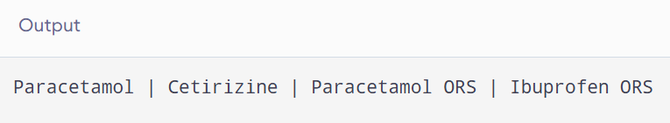
Q3 – Dynamic Constructors and Destructors (7 Marks)
Bloom’s Level: K5 – Evaluate
Problem Context – Auditorium Seat Booking
An auditorium's seat map is created when an event is set up; the number of rows and seats per row differs from event to event. When the event object is destroyed, all memory must be released and a closing summary written.
Implementation Tasks
You must:
- Write a dynamic constructor that allocates a two-dimensional seat map with new.
- Write a destructor that releases every allocation and prints a summary.
- Create events on the stack, on the heap (new/delete) and inside a block.
- Book and cancel seats.
Design & Analysis
You must:
- Explain the order in which constructors and destructors run for local, block-scope and dynamically created objects.
- Explain what happens if delete is forgotten, and if delete is used instead of delete[].
- Explain why the destructor takes no arguments and cannot be overloaded.
- Draw the memory layout of the seat map.
Experimental Investigation
You must:
- Print messages in the constructor and destructor and record the order for each kind of object.
- Run with -fsanitize=address, first with a missing delete and then with the correct code.
- Measure the memory allocated for 10 × 20, 100 × 200 and 1,000 × 2,000 seat maps.
- Test an event with zero rows.
Conclusion
How does tying memory release to the destructor (the RAII idea) make the program safer?
Predict the Output
Write the exact output of the program below BEFORE running it. Then compile and run it, and explain every difference between your prediction and the actual output.
CODE:
#include <iostream>
#include <string>

struct Logger {
std::string n;

Logger(const std::string& s) : n(s) {
std::cout << "+" << n << '\n';
}

Logger(const Logger& o) : n(o.n + "C") {
std::cout << "copy" << n << '\n';
}

~Logger() {
std::cout << "-" << n << '\n';
}
};

void use(Logger) {
std::cout << "use\n";
}

int main()
{
Logger a("A");
{
Logger b("B");
}

use(a);

Logger* p = new Logger("P");
delete p;

std::cout << "end\n";
}
OUTPUT:
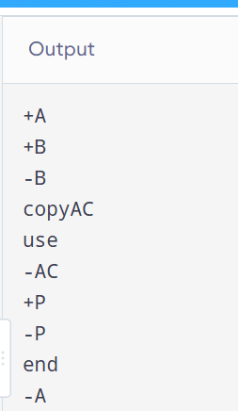
Q4 – Overloading Arithmetic and Stream Operators (7 Marks)
Bloom’s Level: K5 – Evaluate
Problem Context – Money Arithmetic for a Billing Counter
A billing counter adds, subtracts and compares amounts of money stored in rupees and paise. The present code calls functions such as add(a, b) and print(m), which makes the bill calculation hard to read.
Implementation Tasks
You must:
- Write a Money class storing paise in a long long.
- Overload +, -, +=, == and < as appropriate.
- Overload << (and >>) for printing and reading amounts.
- Write the bill calculation using the overloaded operators.
Design & Analysis
You must:
- Explain why + returns a new object while += returns a reference to *this.
- Decide which operators are members and which are friends, and justify each.
- Explain why << must be a non-member function.
- Show how a + b is translated by the compiler into a function call.
Experimental Investigation
You must:
- Test addition that carries paise into rupees (Rs 0.75 + Rs 0.50).
- Test subtraction that produces a negative amount and decide how to handle it.
- Compare the readability of the bill code with and without operator overloading.
- Compare the result with a double-based version for 1,000,000 additions.
Engineering Decision
Should Money allow multiplication by another Money? Decide which operators make sense for money and which do not.
Complete the Code
Complete TODO 1 and TODO 2 below, and execute the program.
CODE:

#include <iostream>
using namespace std;

class Money {
long long rupees;
int paise;

public:
// Constructor
Money(long long r = 0, int p = 0) {
long long total = r * 100 + p;
rupees = total / 100;
paise = total % 100;

if (paise < 0) {
rupees--;
paise += 100;
}
}

// TODO 1: Overload + as a member function
Money operator+(const Money& m) {
long long total1 = rupees * 100 + paise;
long long total2 = m.rupees * 100 + m.paise;

long long total = total1 + total2;

return Money(total / 100, total % 100);
}

// Overload +=
Money& operator+=(const Money& m) {
*this = *this + m;
return *this;
}

// Overload -=
Money& operator-=(const Money& m) {
long long total1 = rupees * 100 + paise;
long long total2 = m.rupees * 100 + m.paise;
long long total = total1 - total2;

rupees = total / 100;
paise = total % 100;

if (paise < 0) {
rupees--;
paise += 100;
}

return *this;
}

// TODO 2: Overload ==
bool operator==(const Money& m) const {
return rupees == m.rupees &&
paise == m.paise;
}

// Friend function for <<
friend ostream& operator<<(ostream& out, const Money& m) {
out << "Rs " << m.rupees << ".";

if (m.paise < 10)
out << "0";

out << m.paise;
return out;
}
};

int main() {
Money a(120, 75), b(79, 25);

Money c = a + b;

cout << c << '\n';
cout << boolalpha << (c == Money(200)) << '\n';

// Test addition with paise carry
Money d(10, 75), e(5, 50);
Money f = d + e;

cout << f << '\n';

return 0;
}
OUTPUT:
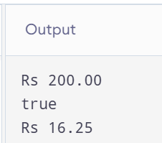
Q5 – Overloading Increment, Comparison and Subscript Operators (6 Marks)
Bloom’s Level: K5 – Evaluate
Problem Context – Music Playlist and Track Timer
A music player keeps a playlist of tracks and a Time object for the current position. The player needs time++ and ++time to advance by one second, comparisons between times, and playlist[i] to reach the i-th track with a range check.
Implementation Tasks
You must:
- Overload prefix and postfix ++ for Time.
- Overload == and < for Time.
- Overload [] for Playlist with a range check, in both a const and a non-const version.
- Use the operators in a short playback simulation.
Design & Analysis
You must:
- Explain how the compiler tells prefix from postfix ++ (the int dummy parameter).
- Explain why postfix ++ must return a copy and is slower.
- Explain why operator[] needs a const and a non-const version.
- Explain what should happen when an index is out of range.
Experimental Investigation
You must:
- Verify the values of a and b after a = t++ and b = ++t.
- Measure the time of 10,000,000 prefix and postfix increments at -O0 and -O2.
- Test playlist[-1] and playlist[size].
- Test minute and hour roll-over (59:59 → 1:00:00).
Conclusion
Why do many programmers prefer ++i to i++ for class types?
Predict the Output
Write the exact output of the program below BEFORE running it. Then compile and run it, and explain every difference between your prediction and the actual output.
CODE:

#include <iostream>
#include <vector>
#include <string>
#include <stdexcept>
using namespace std;

// Counter class
class Counter {
public:
int v;

Counter(int x = 0) {
v = x;
}

// Prefix increment
Counter& operator++() {
++v;
return *this;
}

// Postfix increment
Counter operator++(int) {
Counter old = *this;
v++;
return old;
}
};

// Time class
class Time {
public:
int hour, minute, second;

Time(int h = 0, int m = 0, int s = 0) {
hour = h;
minute = m;
second = s;
}

// Prefix increment
Time& operator++() {
second++;

if (second == 60) {
second = 0;
minute++;
}

if (minute == 60) {
minute = 0;
hour++;
}

if (hour == 24)
hour = 0;

return *this;
}

// Postfix increment
Time operator++(int) {
Time old = *this;
++(*this);
return old;
}

// Equality operator
bool operator==(const Time& t) const {
return hour == t.hour &&
minute == t.minute &&
second == t.second;
}

// Not equal operator
bool operator!=(const Time& t) const {
return !(*this == t);
}

void display() const {
cout << hour << ":"
<< minute << ":"
<< second << endl;
}
};

// Playlist class
class Playlist {
vector<string> tracks;

public:
Playlist(vector<string> t) {
tracks = t;
}

// Non-const subscript operator
string& operator[](int index) {
return tracks.at(index);
}

// Const subscript operator
const string& operator[](int index) const {
return tracks.at(index);
}

int size() const {
return tracks.size();
}
};

int main() {

// Counter demonstration
Counter c(5);

Counter a = c++;
Counter b = ++c;

cout << a.v << " "
<< b.v << " "
<< c.v << endl;

// Time demonstration
Time t(12, 30, 59);

cout << "Postfix: ";
(t++).display();

cout << "Prefix: ";
(++t).display();

Time t2(12, 31, 1);

cout << boolalpha;
cout << "Equal: " << (t == t2) << endl;
cout << "Not Equal: " << (t != t2) << endl;

// Playlist demonstration
Playlist p({"Song A", "Song B", "Song C"});

cout << "Playlist:" << endl;

for (int i = 0; i < p.size(); i++) {
cout << p[i] << endl;
}

// Change a track using non-const operator
p[1] = "New Song";

cout << "Updated Track: " << p[1] << endl;

// Range checking
try {
cout << p[5] << endl;
}
catch (const out_of_range& e) {
cout << "Invalid track index!" << endl;
}

return 0;
}
OUTPUT:
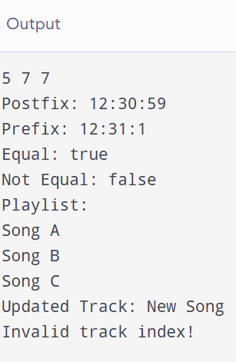
Q6 – The Rules of Operator Overloading (7 Marks)
Bloom’s Level: K5 – Evaluate
Problem Context – A Simple Text Class for an SMS Gateway
An SMS gateway uses its own Text class (holding a dynamically allocated character array) so that it can control memory carefully. It needs assignment, concatenation with +, comparison and printing.
Implementation Tasks
You must:
- Implement Text with a constructor, copy constructor, copy assignment and destructor.
- Overload + for concatenation, == and != for comparison and << for printing.
- Prevent self-assignment problems.
- Test long messages and empty messages.
Design & Analysis
You must:
- List the operators that cannot be overloaded (::, ., .*, ?:, sizeof) and explain why.
- Explain the rules: precedence and arity cannot change, at least one operand must be a user-defined type.
- Explain why operator= must be a member function.
- Explain when an overloaded operator should be a friend.
Experimental Investigation
You must:
- Count the copies made when a + b + c is evaluated.
- Run the program under the address sanitizer and fix any reported error.
- Compare your Text class with std::string for 100,000 concatenations.
- Test assigning a Text to itself.
Conclusion
Your Text class works, but std::string exists. What did writing Text teach you, and when would you still write such a class?
Alternative Concept and Complexity Analysis
If the Text class were replaced by std::string, or if + were implemented with += on a copy (Text operator+(Text a, const Text& b) { a += b; return a; }), what would the solution be? Analyse the time to evaluate a + b + c for strings of lengths n1, n2, n3 (the characters copied) and the temporary space created in each version.
CODE:

#include <iostream>
#include <cstring>
using namespace std;

class Text {
private:
char* data;

public:
// Constructor
Text(const char* str = "") {
if (str == nullptr)
str = "";

data = new char[strlen(str) + 1];
strcpy(data, str);
}

// Copy constructor
Text(const Text& other) {
data = new char[strlen(other.data) + 1];
strcpy(data, other.data);
}

// Copy assignment operator
Text& operator=(const Text& other) {
if (this != &other) {
char* temp = new char[strlen(other.data) + 1];
strcpy(temp, other.data);

delete[] data;
data = temp;
}
return *this;
}

// Overload + for concatenation
Text operator+(const Text& other) const {
int len = strlen(data) + strlen(other.data);

char* temp = new char[len + 1];

strcpy(temp, data);
strcat(temp, other.data);

Text result(temp);

delete[] temp;

return result;
}

// Overload == for comparison
bool operator==(const Text& other) const {
return strcmp(data, other.data) == 0;
}

// Overload != for comparison
bool operator!=(const Text& other) const {
return !(*this == other);
}

// Friend function for printing
friend ostream& operator<<(ostream& out, const Text& t) {
out << t.data;
return out;
}

// Destructor
~Text() {
delete[] data;
}
};

int main() {

// Create Text objects
Text a("Hello ");
Text b("World");
Text c("!");

// Concatenation
Text result = a + b + c;

cout << "Concatenated Text: " << result << endl;

// Comparison
Text x("Hello");
Text y("Hello");

cout << boolalpha;
cout << "Equal: " << (x == y) << endl;
cout << "Not Equal: " << (x != y) << endl;

// Copy constructor
Text copy = a;
cout << "Copied Text: " << copy << endl;

// Self assignment
a = a;
cout << "Self Assignment: " << a << endl;

// Empty message
Text empty("");
cout << "Empty Text: [" << empty << "]" << endl;

// Long message
Text longMsg("This is a long message for testing dynamic memory allocation.");
cout << "Long Message: " << longMsg << endl;

return 0;
}
OUTPUT:
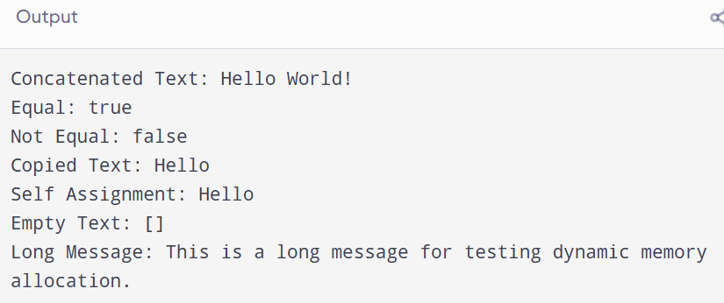
Q7 – Design a Complex-Number Class from First Principles (10 Marks)
Bloom’s Level: K5 – Evaluate
Problem Context – AC Circuit Impedance Calculator
An electrical engineering laboratory needs a calculator for AC circuits. Impedances are complex numbers: resistors give R + 0j, inductors 0 + jωL and capacitors 0 − j/(ωC). Series impedances add; parallel impedances combine as (Z1 × Z2) / (Z1 + Z2). The calculator must print the impedance in rectangular form and its magnitude, and must handle division by zero safely.
You are not given the design. You must develop it from the requirements.
Stage 1 – Interpret the Problem (2 Marks)
- Identify the data and the operations needed.
- Identify which constructors are needed (default, from real part, from real and imaginary parts).
- State the requirements as measurable statements.
Stage 2 – Design (3 Marks)
- Design the Complex class with constructors and overloaded +, -, *, /, == and <<.
- Decide which operators are members and which are friends.
- Present the class design and the formula used for each operator.
Stage 3 – Implement and Verify (3 Marks)
- Implement the class and compute the impedance of a series and a parallel RLC circuit.
- Verify the results by hand calculation.
- Test division by a zero impedance.
Stage 4 – Defend the Design (2 Marks)
- Compare your class with std::complex<double>.
- Explain why each constructor and operator is needed.
- Identify one remaining limitation.
Alternative Concept and Complexity Analysis
If std::complex<double> were used instead of your own Complex class, what would the solution be? Analyse the time per operation (O(1) in both) and the space (two doubles in both), and compare accuracy and the work needed to handle division by zero.
Submission Requirements
GitHub repository link (mandatory) containing the executed code for every task, including every completed “Complete the Code” program, with input files, output screenshots and a README.md.
- Your report containing the required evidence for Q1–Q7.
- C++ source code for all questions.
- Predictions, outputs, memory diagrams, sanitizer reports and timings.
Assessment Verification
Students may be asked to explain, execute or modify any part of their design, code, tests or results during a brief verification discussion/viva. The student should be able to explain and defend the work submitted as their own.
CODE:

#include <iostream>
#include <cmath>
#include <iomanip>
#include <stdexcept>
using namespace std;

class Complex {
private:
double real;
double imag;

public:
// Default constructor
Complex() {
real = 0;
imag = 0;
}

// Constructor with real part
Complex(double r) {
real = r;
imag = 0;
}

// Constructor with real and imaginary parts
Complex(double r, double i) {
real = r;
imag = i;
}

// Addition operator
Complex operator+(const Complex& c) const {
return Complex(real + c.real, imag + c.imag);
}

// Subtraction operator
Complex operator-(const Complex& c) const {
return Complex(real - c.real, imag - c.imag);
}

// Multiplication operator
Complex operator*(const Complex& c) const {
return Complex(
real * c.real - imag * c.imag,
real * c.imag + imag * c.real
);
}

// Division operator
Complex operator/(const Complex& c) const {
double denominator =
c.real * c.real + c.imag * c.imag;

if (denominator == 0.0) {
throw runtime_error("Division by zero impedance");
}

return Complex(
(real * c.real + imag * c.imag) / denominator,
(imag * c.real - real * c.imag) / denominator
);
}

// Equality operator
bool operator==(const Complex& c) const {
return real == c.real && imag == c.imag;
}

// Calculate magnitude
double magnitude() const {
return sqrt(real * real + imag * imag);
}

// Friend function for output
friend ostream& operator<<(ostream& out, const Complex& c) {
out << c.real;

if (c.imag >= 0)
out << " + " << c.imag << "j";
else
out << " - " << -c.imag << "j";

return out;
}
};

int main() {
cout << fixed << setprecision(2);

// Resistor, Inductor and Capacitor
Complex R(10, 0);
Complex L(0, 6);
Complex C(0, -2);

// Series RLC impedance
Complex Zseries = R + L + C;

cout << "Series Impedance: " << Zseries << endl;
cout << "Series Magnitude: "
<< Zseries.magnitude() << endl;

// Parallel circuit
Complex Z1(10, 6);
Complex Z2(0, -2);

Complex Zparallel = (Z1 * Z2) / (Z1 + Z2);

cout << "\nParallel Impedance: "
<< Zparallel << endl;

cout << "Parallel Magnitude: "
<< Zparallel.magnitude() << endl;

// Arithmetic operations
Complex a(5, 3);
Complex b(2, 1);

cout << "\nAddition: " << a + b << endl;
cout << "Subtraction: " << a - b << endl;
cout << "Multiplication: " << a * b << endl;
cout << "Division: " << a / b << endl;

// Comparison
cout << boolalpha;
cout << "Equality: " << (a == b) << endl;

// Division by zero test
try {
Complex zero(0, 0);
Complex result = a / zero;
cout << result << endl;
}
catch (const runtime_error& e) {
cout << "Error: " << e.what() << endl;
}

return 0;
}
OUTPUT:


